**Grocery Website**

**Okay so firstly we make a structured design in which we design frontend pages of our website ....**

**Start with landing or home page...**

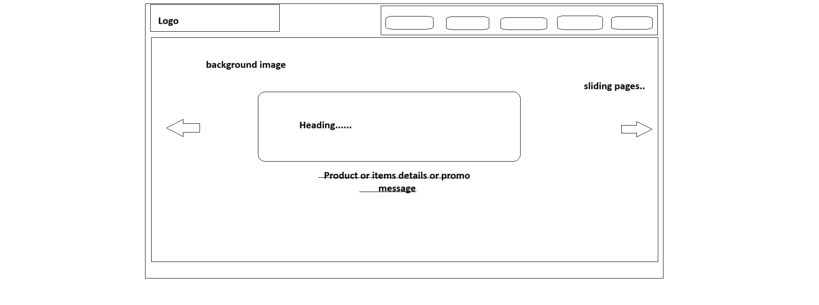**.......**

**Now switch to our second page in which we make items card ,**

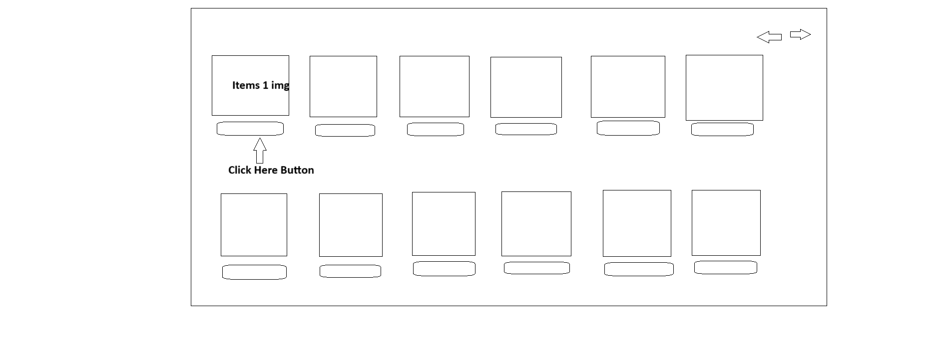**....So here you see Lots of box and buttons each box contain images of items which sell by store manager like rice,wheat,softdrinks,....etc.**

**Now when user click on “click here” button a new page open which contain complete details about product.**

**................................**

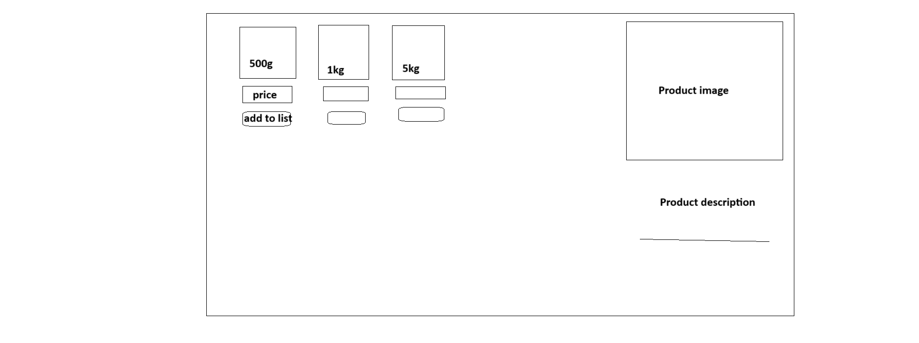**..Now comes to next page...**

**After add the items user switch back to the home page for adding more items...**

**For view list of added items user click on #cart link on home page**

**When click on cart a New page open which is items list...**

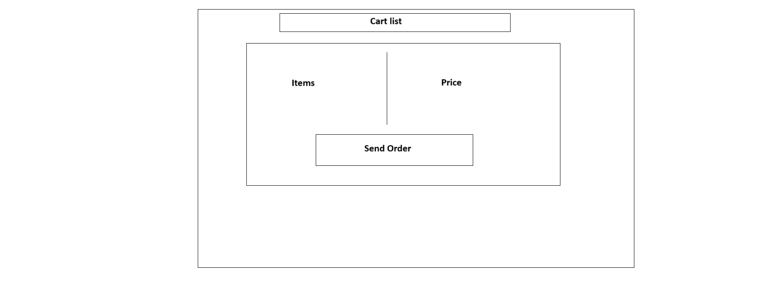**...In cart list as you see user see all the items and price and then user click on send order for completing this step...**

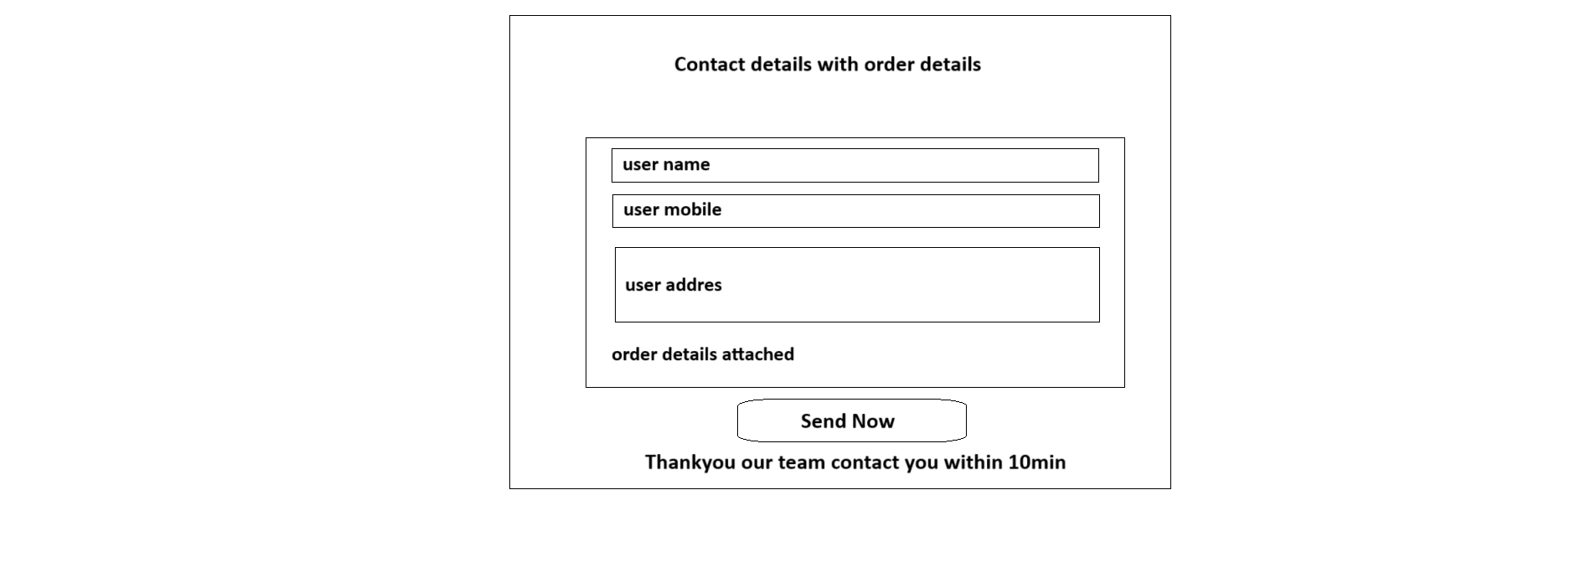

**User must be filled all required details like Name,Mobile,Address and item list attached automatically ....**

**Now click on “send Now” basically in backend send now button Send the all the details of this form to admin and admin team contact to the user within 10-15 min for confirmation the order...**

**Once order confirmed by userside store delivered the items.**

**Okay so now we go back to our design above All three pages comes under “items card”**

**............................**

